

Sport Pack

[Trifles Games](http://www.triflesgames.com/) has provided for you 👾

This is a low polygon city package that you can use for your games. You can find **Basketball Court, Tennis Court, Formula 1 Track, Ice Hockey Field**. You can build up your own Sport Games.

**(The detailed demo scenes is included).**

This pack contains **150** unique low poly models to easily prototype and create a Sport areas.

All models have a prefab ready to put in the scene. Some parts have children objects for flexible controls

**You can check the screenshots for detailed review.**

In order to get the best performance, a single texture atlas is used on all objects.

**Follow us!** Trifles Games ♥  [APPSTORE](https://apps.apple.com/us/developer/trifles-games/id1552634317#see-all/i-phonei-pad-apps) ♥ [LINKEDIN](https://www.linkedin.com/company/trifles-games/) ♥ [INSTAGRAM](https://instagram.com/triflesgames) ♥

1

First of all, you need to install post processing asset from the package manager.

You can install it from Windows->Package Manager and search for post processing.

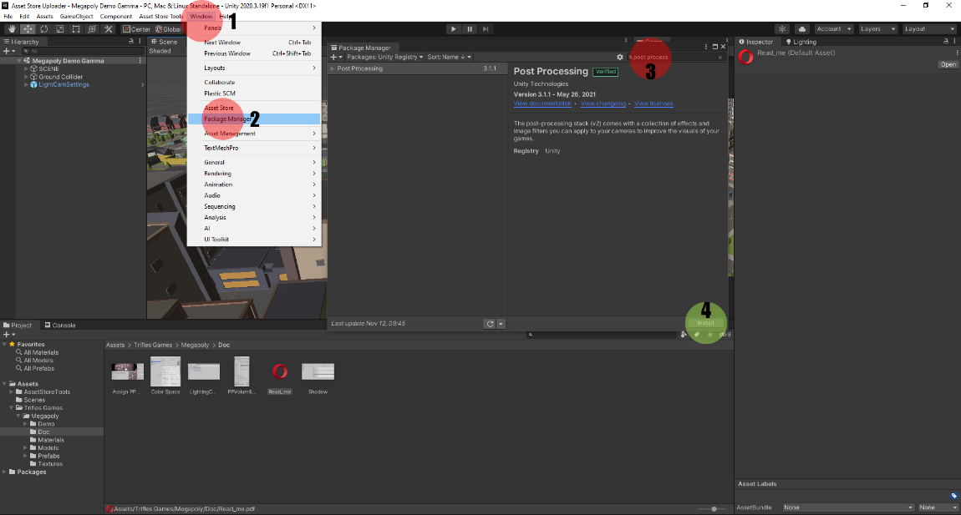

Then remove "Post Process Volume" and "Post Process Layer" from the "Main Camera"

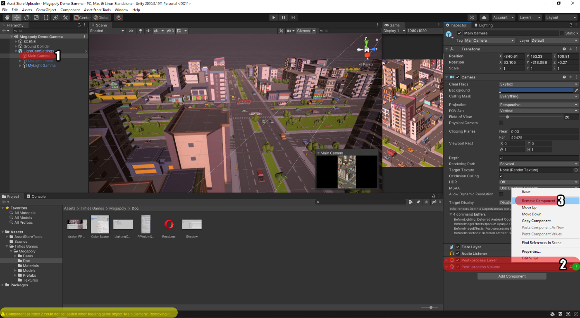

and then add them again to Main camera (Unity can cause bug, that is why we delete and add again) assign MegapolyPP profile to profile in the Main camera. Screen shots are in Doc folder.

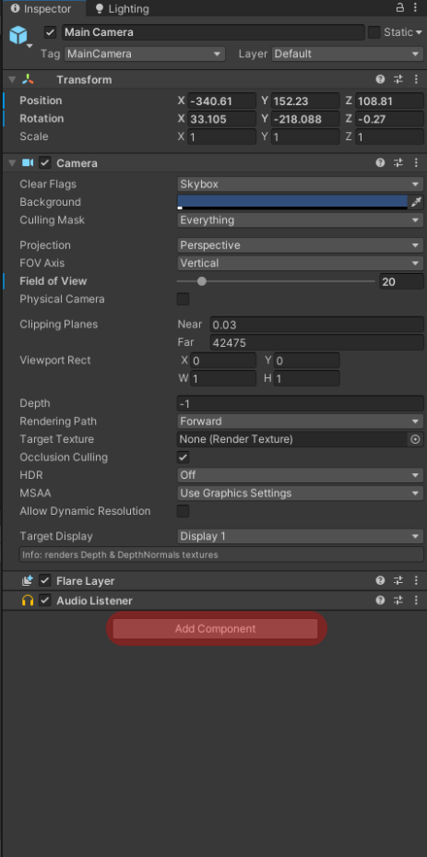 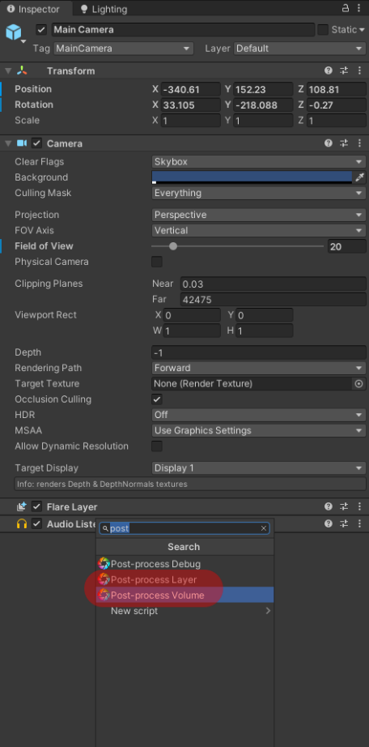 metin içeren bir resim

Açıklama otomatik olarak oluşturuldu

To get same result, you have to change your project settings. We put settings for shadow and pixel light count as screen shot. You can open for it from

Edit > Project Setting > Quality

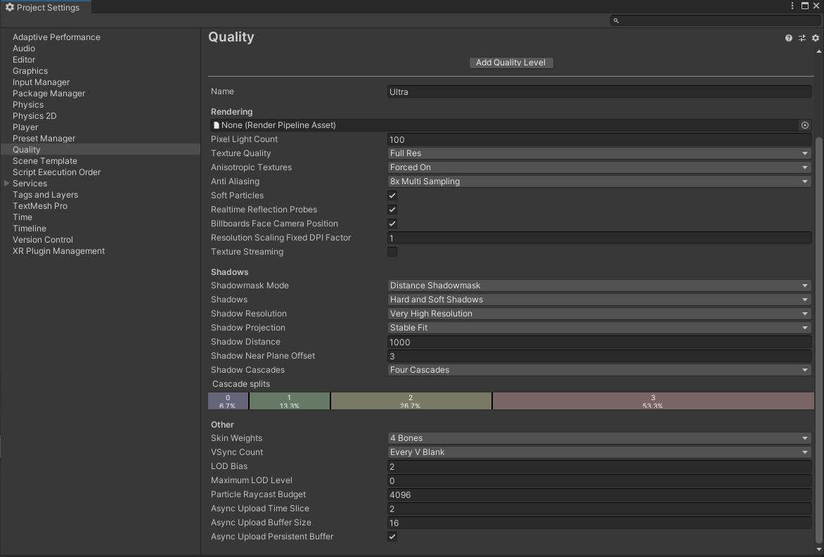

Thank you for purchase



[Trifles Games](https://triflesgames.com/)

[www.triflesgames.com](http://www.triflesgames.com)

[support@triflesgames.com](mailto:support@triflesgames.com)